Leung, Cristian K (Student)

Local AI Lab

Purpose
The purpose of this lab was to explore ways to implement AI locally and make a UI to allow others to connect to it.
Background Information
Artificial intelligence (AI) is a technology that allows computers to do tasks that require human intelligence, expanding the capabilities of computers. Recently a type of AI called language systems have become really popular especially with models like ChatGPT, Gemini, Llama, and Claude.
Large language models (LLM) are a specific type of AI trained on a bunch of text like articles, books, and websites to understand, imitate, and generate human language. It uses probability to figure out tasks like translation, summarization, and answering questions.
Local AI just means running the AI model directly on a user’s computer instead of accessing it through the internet like chatgpt.com. Using Local AI doesn’t require sending data to servers leading to increased privacy and removing the dependence on internet. It also gives the user more control over the AI system.
Ollama is a software tool that helps users download and run LLM’s locally on their device. It heavily simplifies the process by dealing with the system configuration and model downloads. Ollama basically helps people easily install local AI without advanced programming knowledge.
Docker is a software platform that allows applications to run in isolated environments called containers. It is also commonly used to make software easier to install, share, and manage. A container contains everything an application needs to run such as code, libraries, and settings. This allows the application to run the same on different devices keeping consistency.
Powershell is a command-line tool developed by Microsoft which allows users to control their computer and make configurations by typing commands. It’s very commonly used to run programs, manage system settings, and automate tasks.
Web-GUI is a visual interface that runs in a web browser. It allows users to interact with software using simpler options like buttons and menus instead of typing commands. It allows people without technical experience to easily configure and change software settings.

Lab Summary
Go to https://ollama.com/ to download Ollama
Choose your version and click download
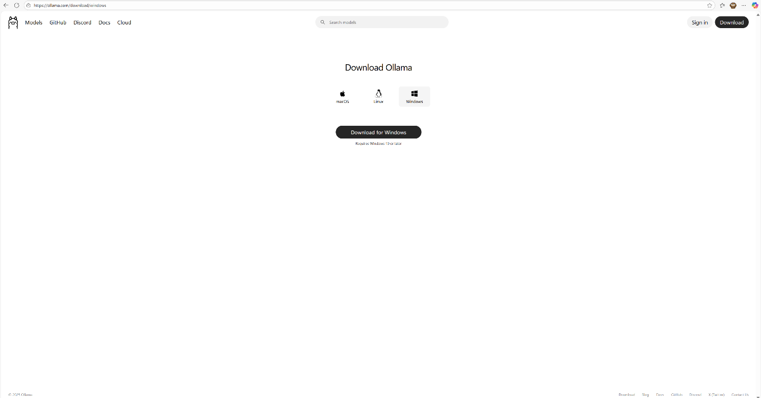
You should see this popup, click open file
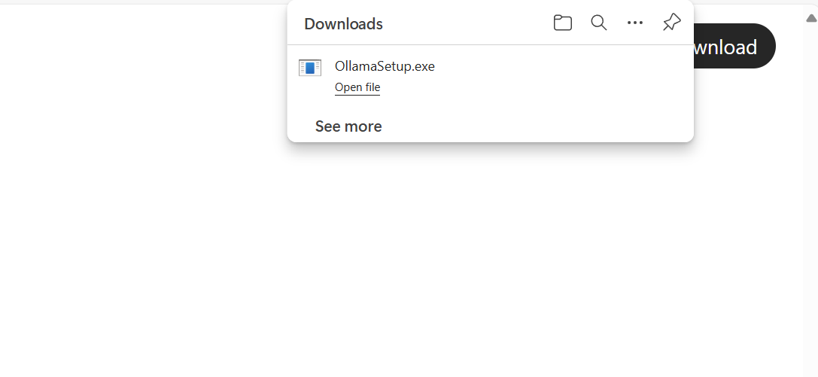
Go ahead and click Install
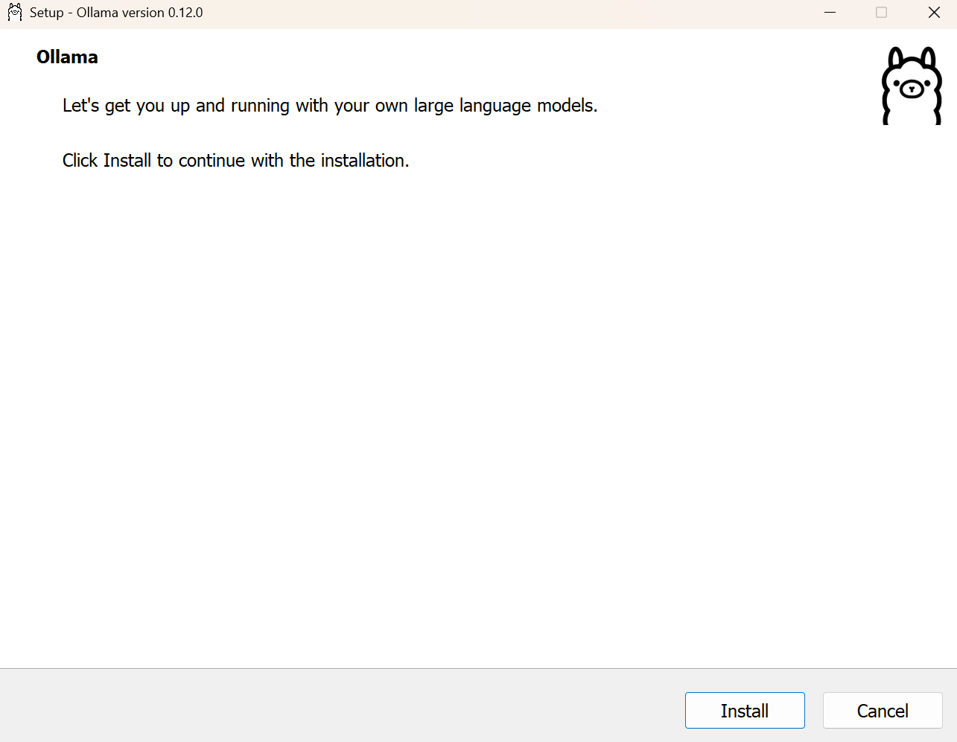
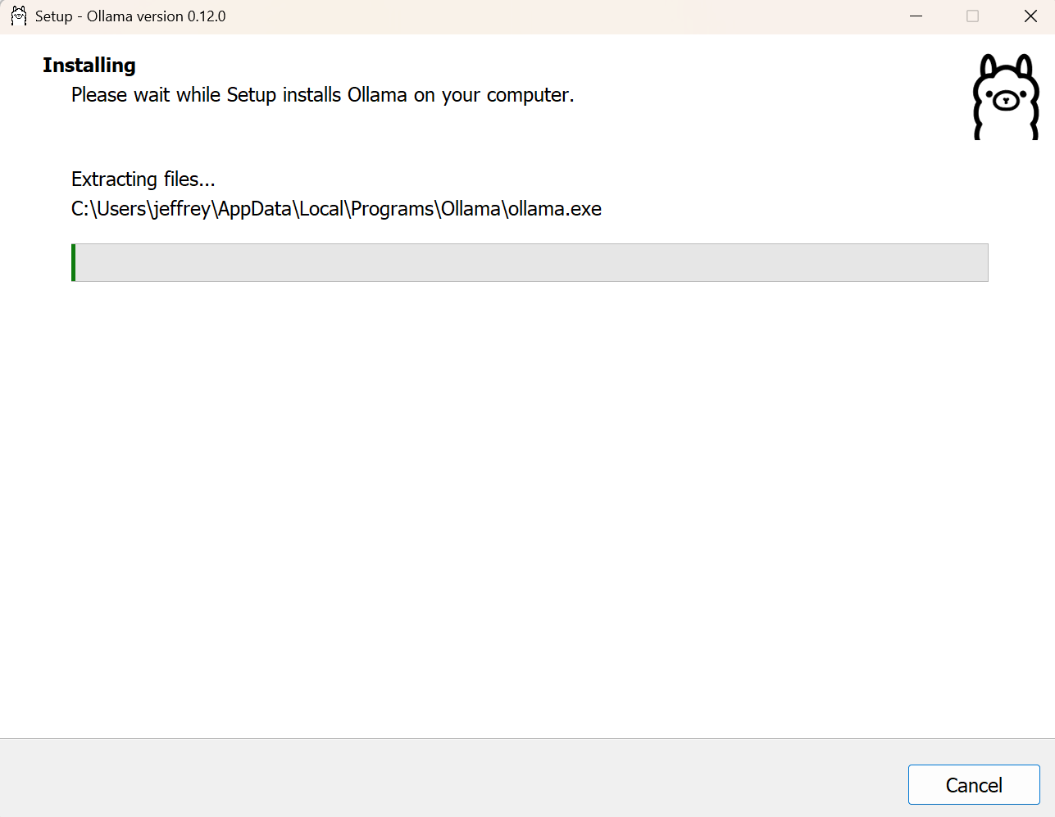
After it finishes downloading, run Ollama. You should see this page, give it a prompt and it will prompt you to download a model, go ahead and download it
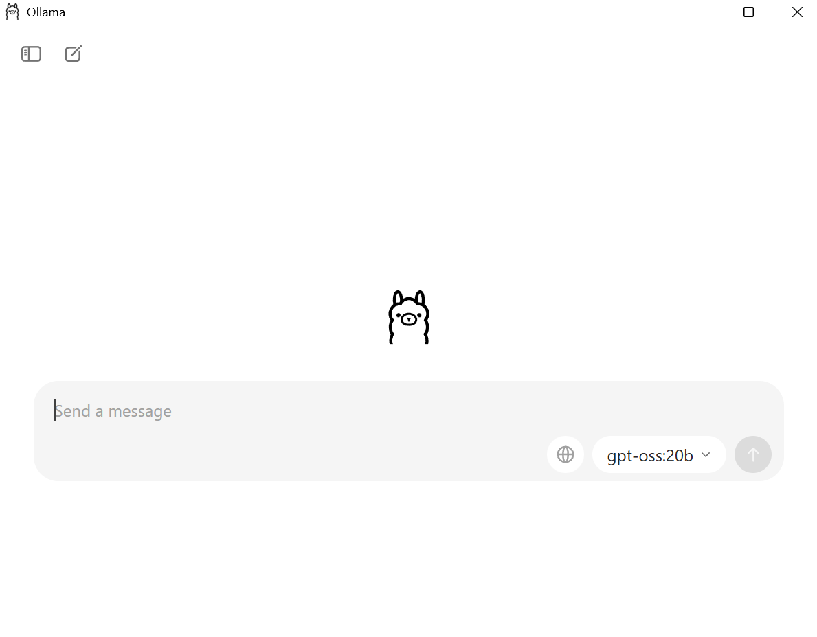
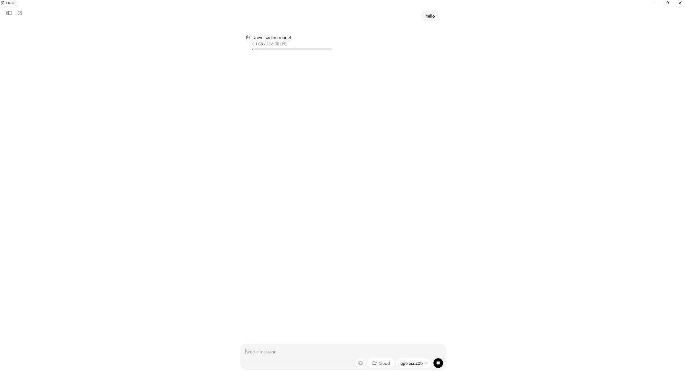
This will take some time, so as we wait you can download Docker from their website: https://www.docker.com/
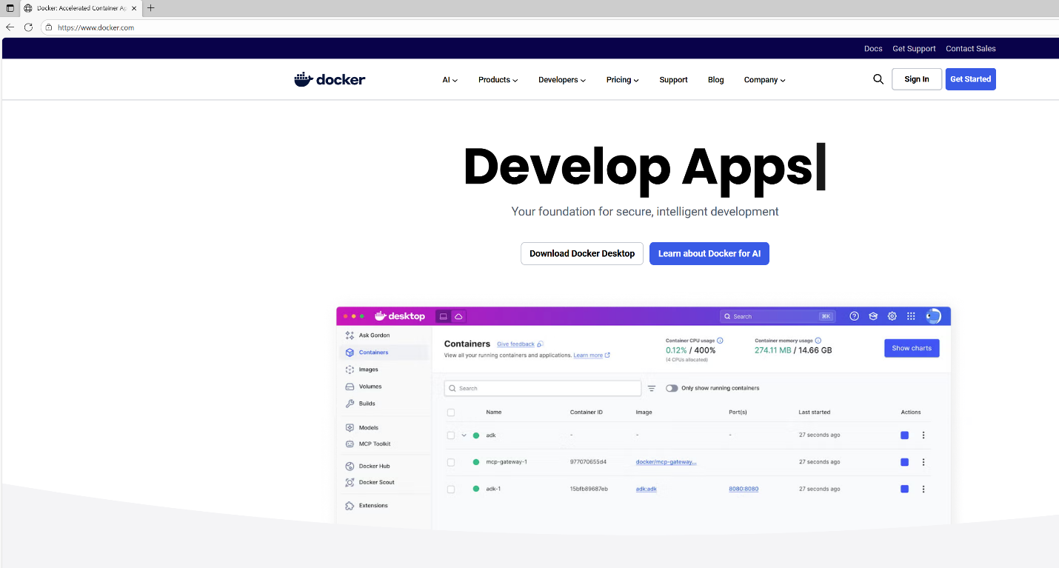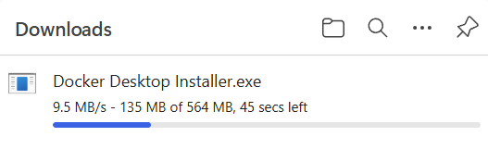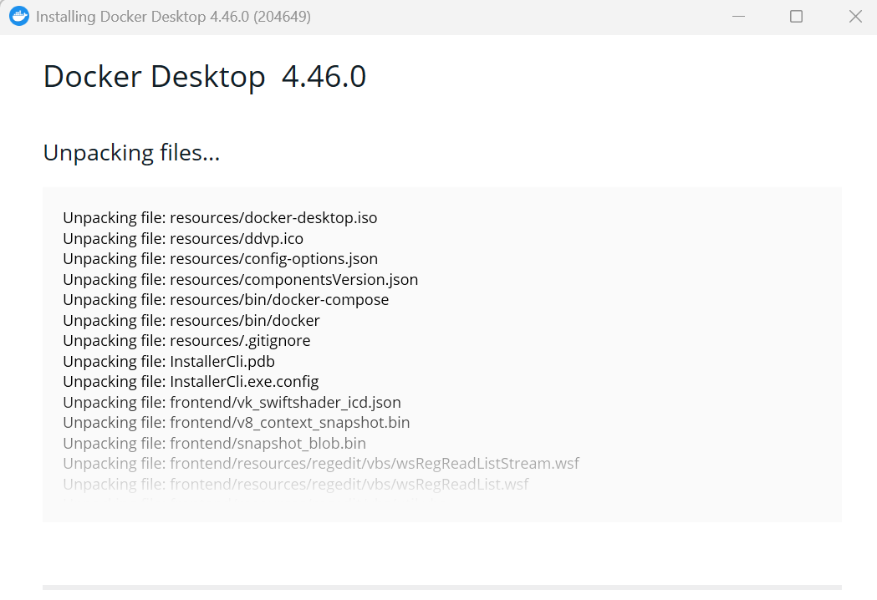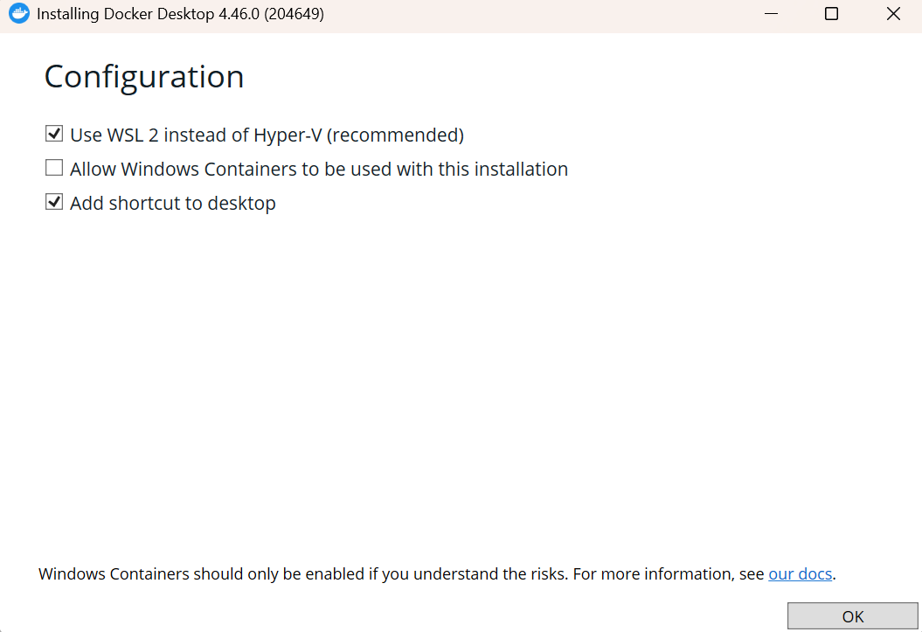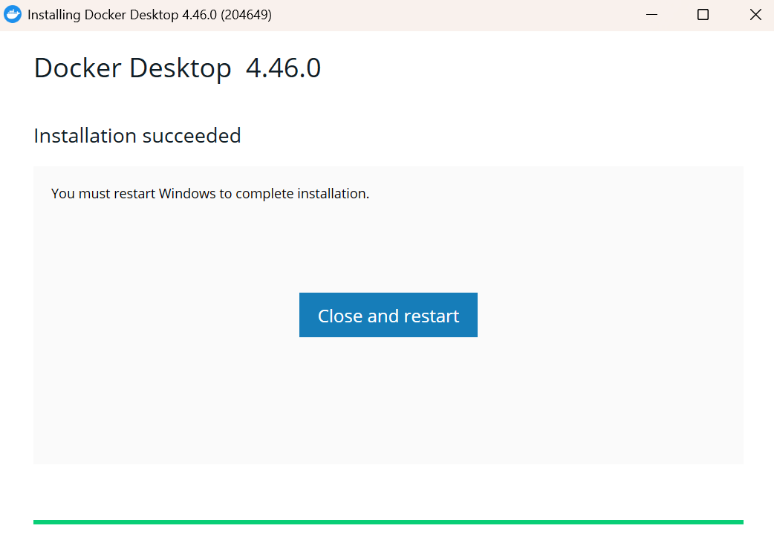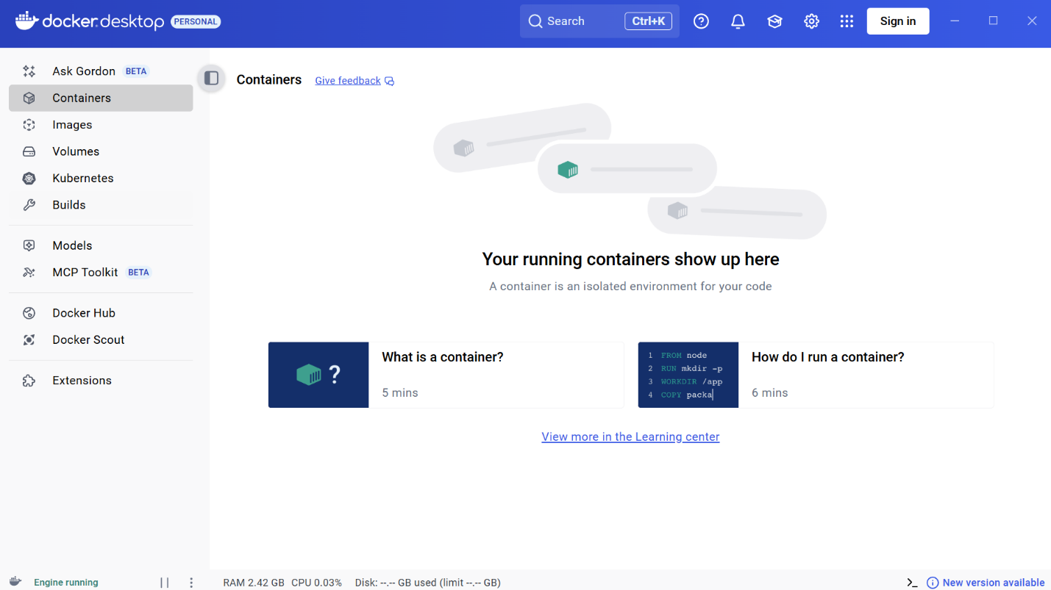
After finishing the download and restarting your device it will ask you to login/sign up. You can do it if you want to keep progress between devices but it’s entirely optional.
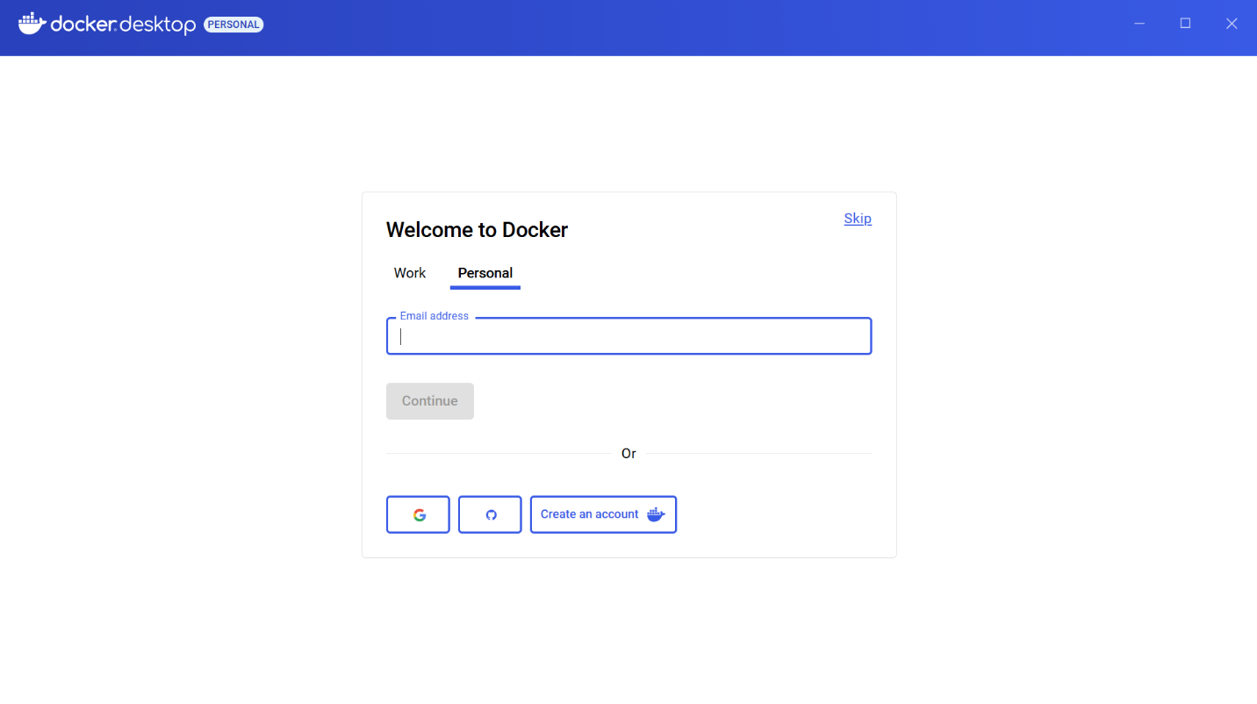
When launching Docker if you see this screen you will need these few extra steps:
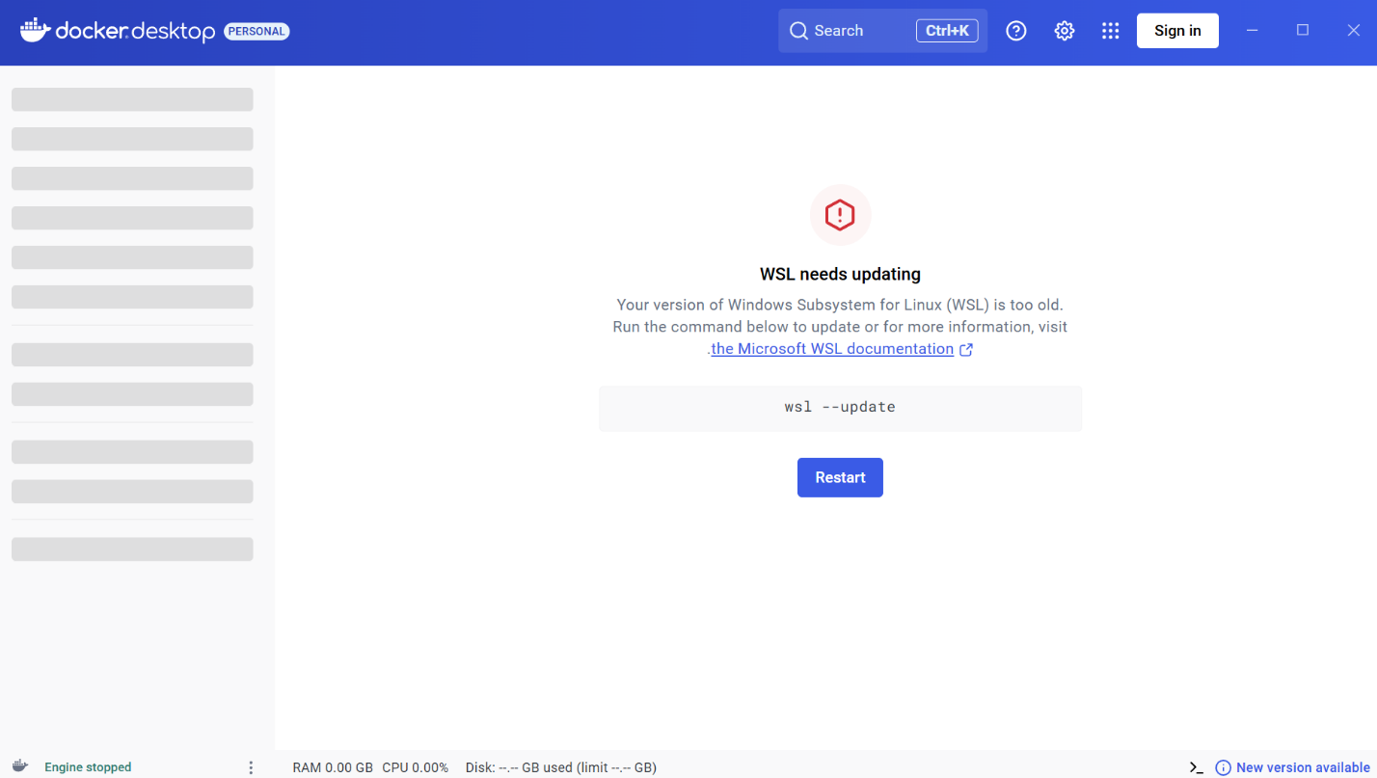
Launch PowerShell and enter the command wsl -update, your screen should look like this:
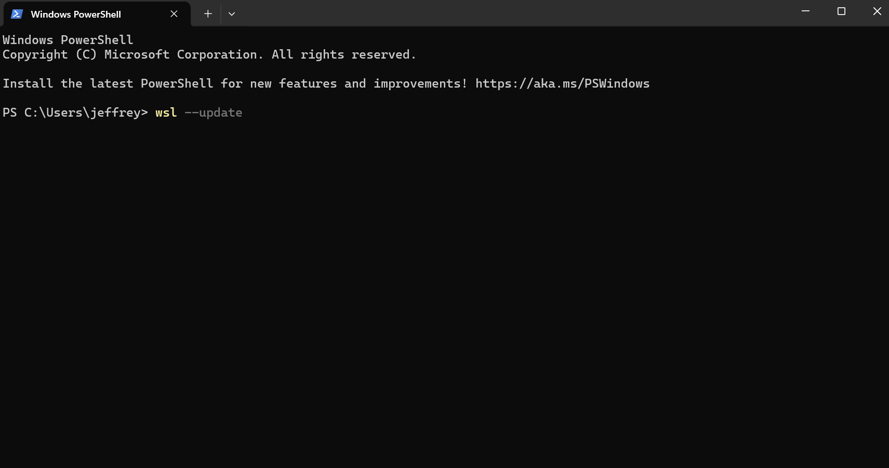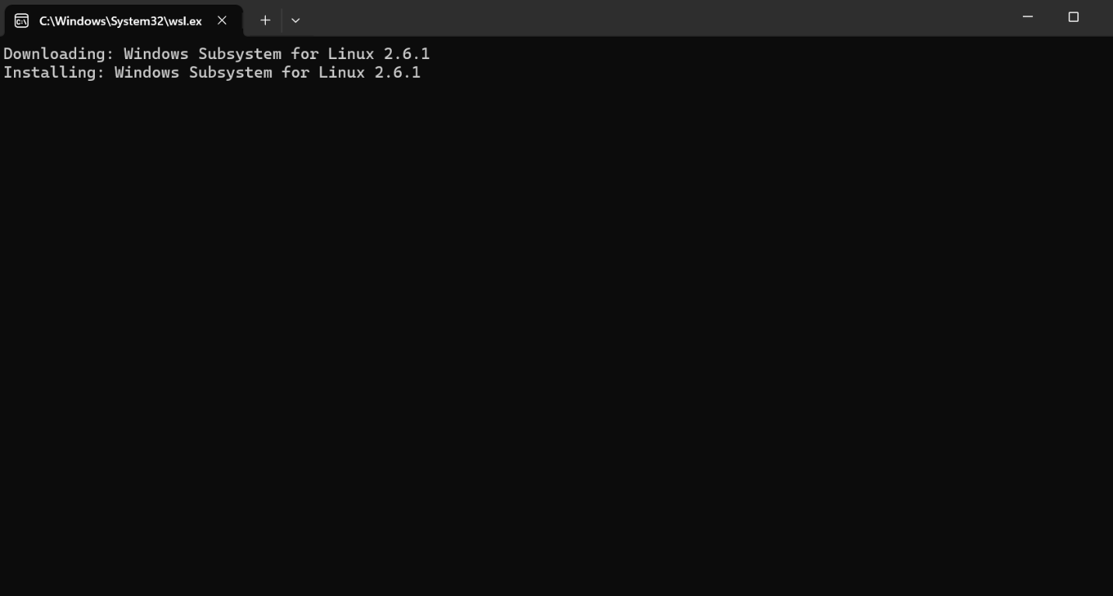
When Ollama finishes installing you can use PowerShell to communicate with Ollama as if PowerShell was the chat: 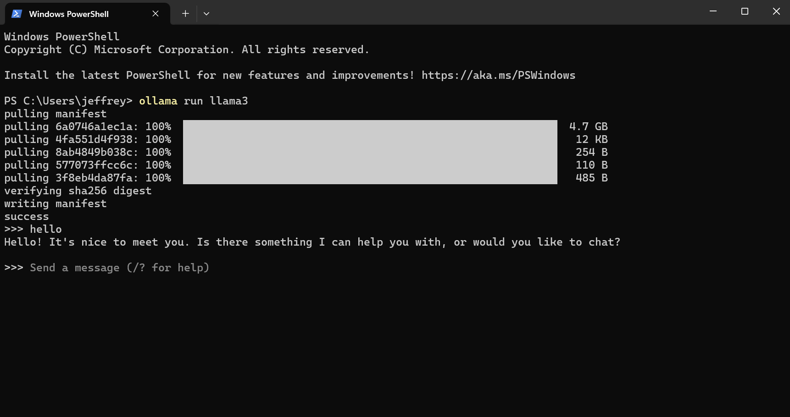
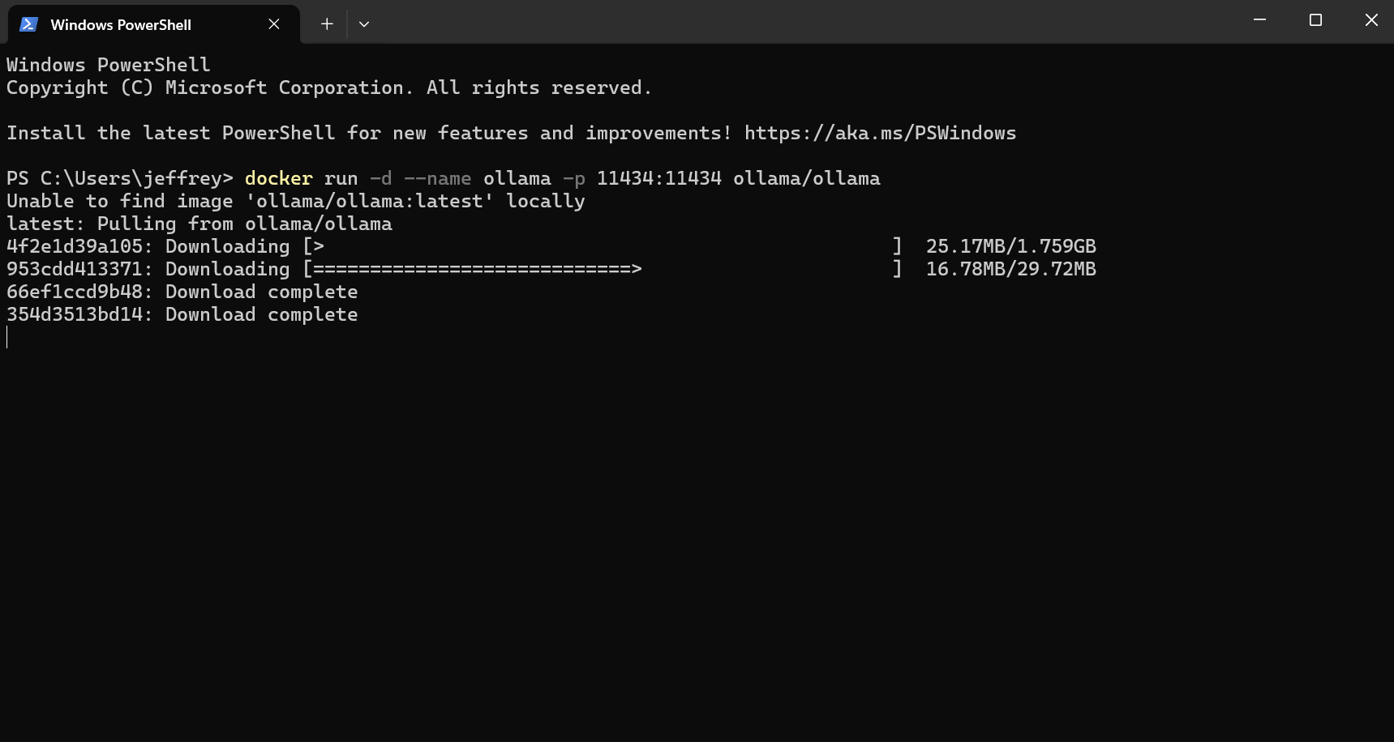
Next use this command “docker run -d -name ollama -p 11434:11434 ollama/ollama command”
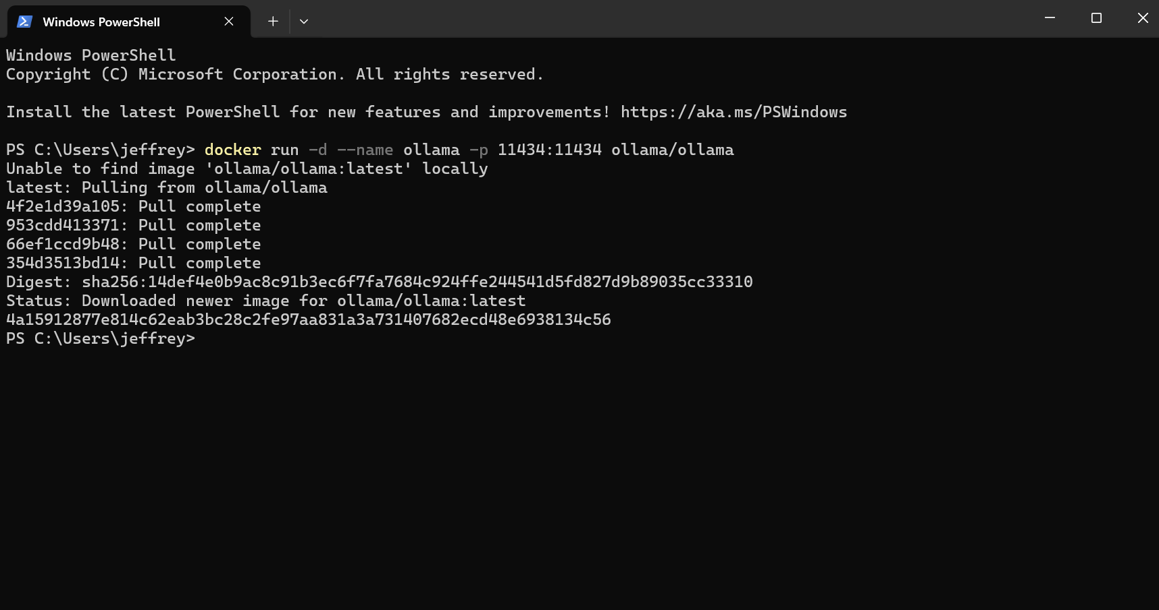
Once you see all the pull completes it’s finished. You should be able to see it in the containers page in docker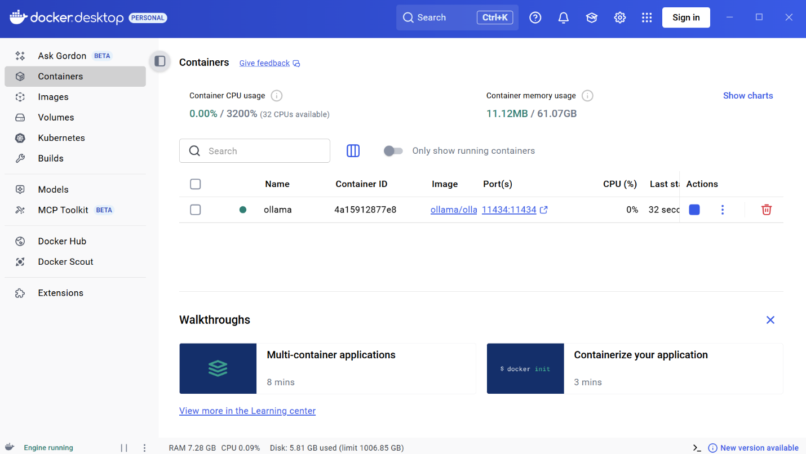
Run the “docker run -d -p 3000:8080 –name open-webui –restart=always” command in PowerShell
This command uses a preset OpenWebUI GUI for our Ollama model
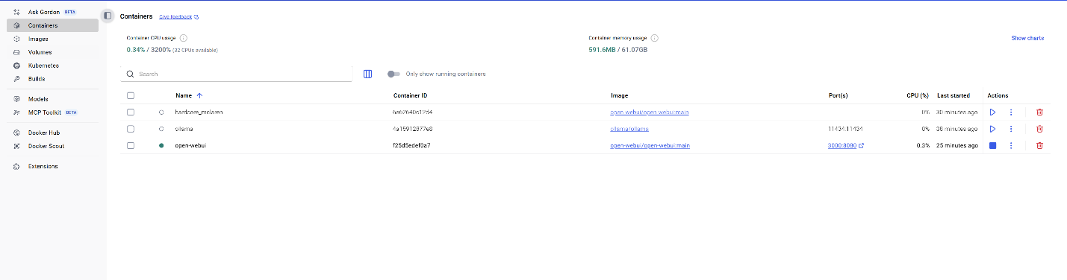
Open it by using this link https://localhost:3000 or by going to docker and clicking on the port
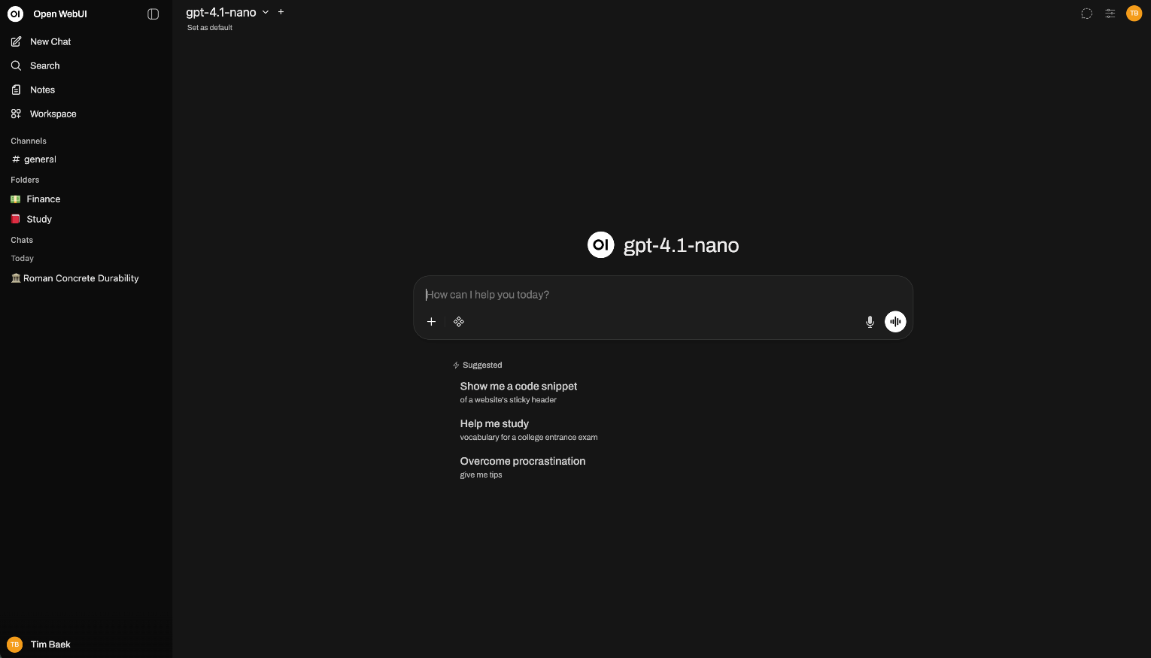
You can also make a custom GUI for the local AI but you will have to code it from scratch. If you want to do this, create html, json, and css files. Here’s some examples: 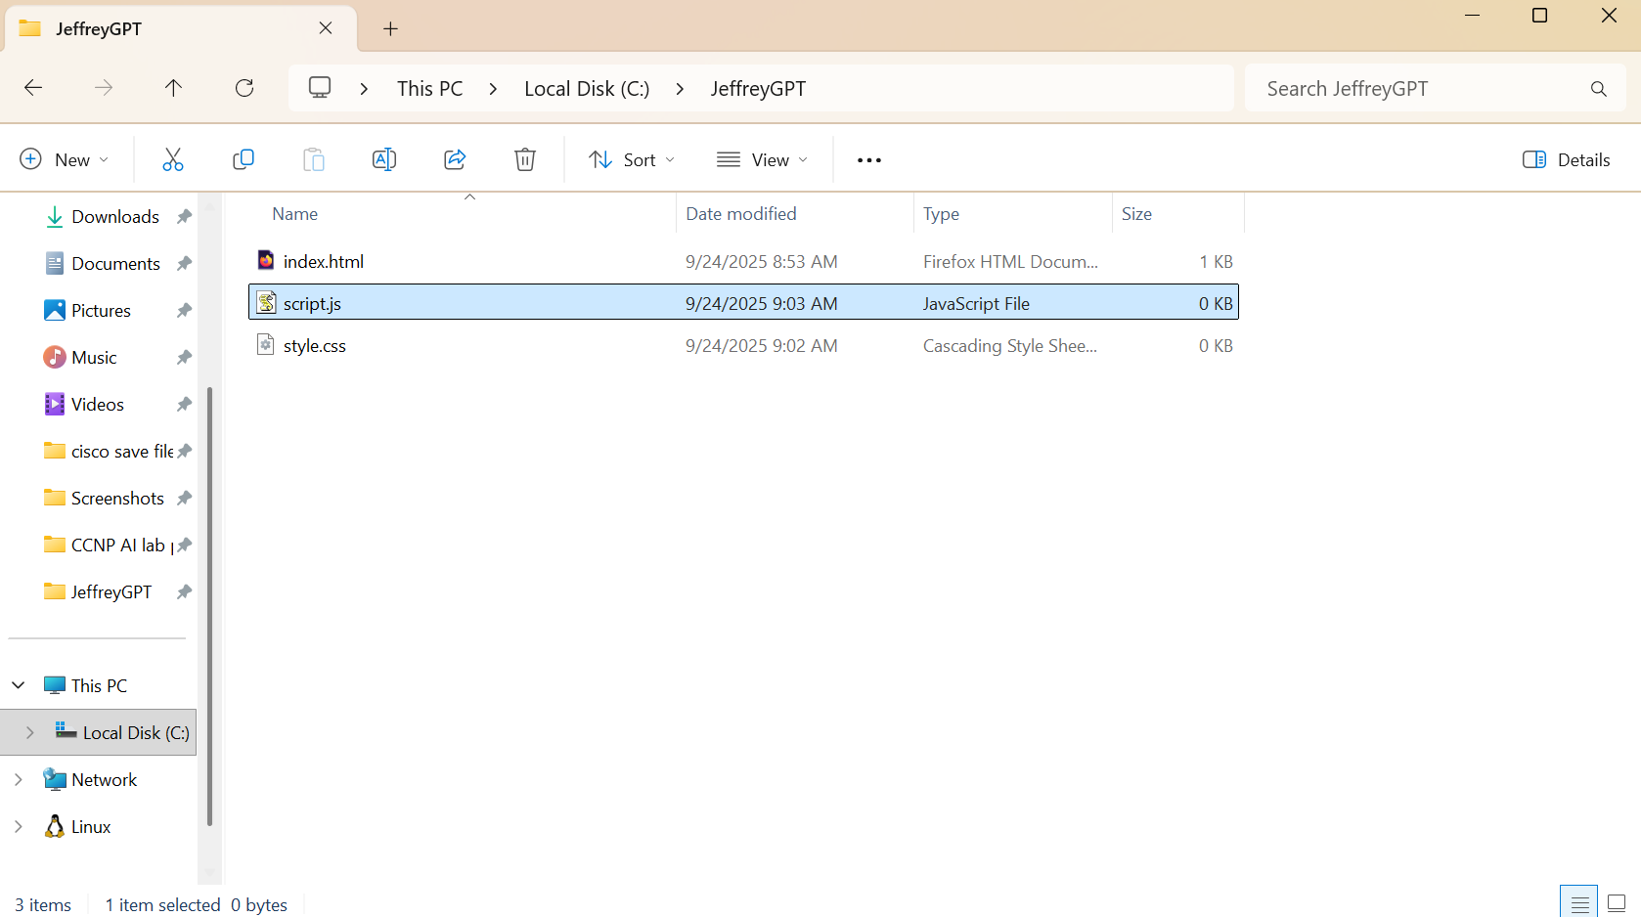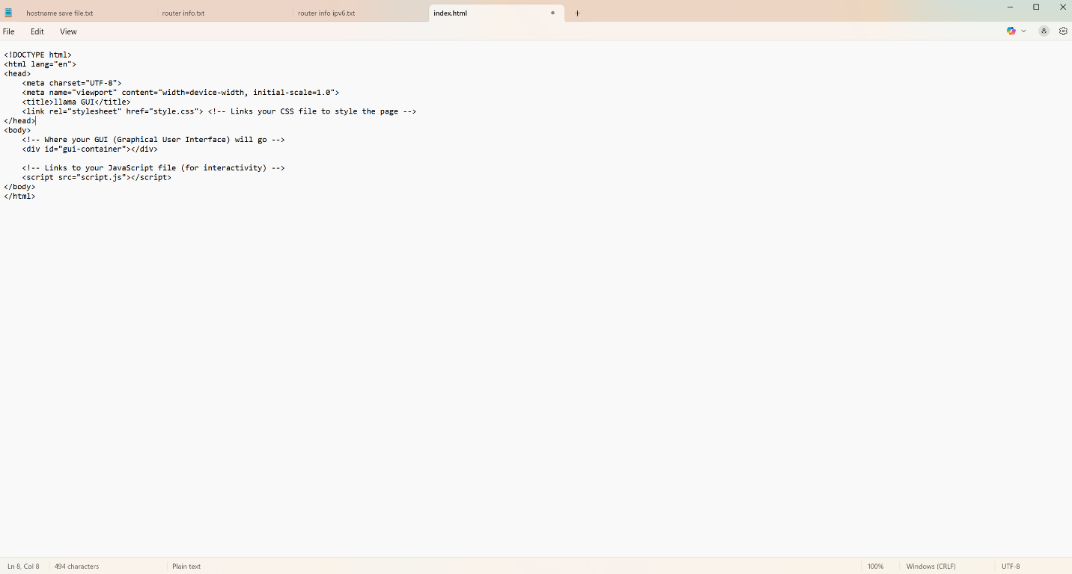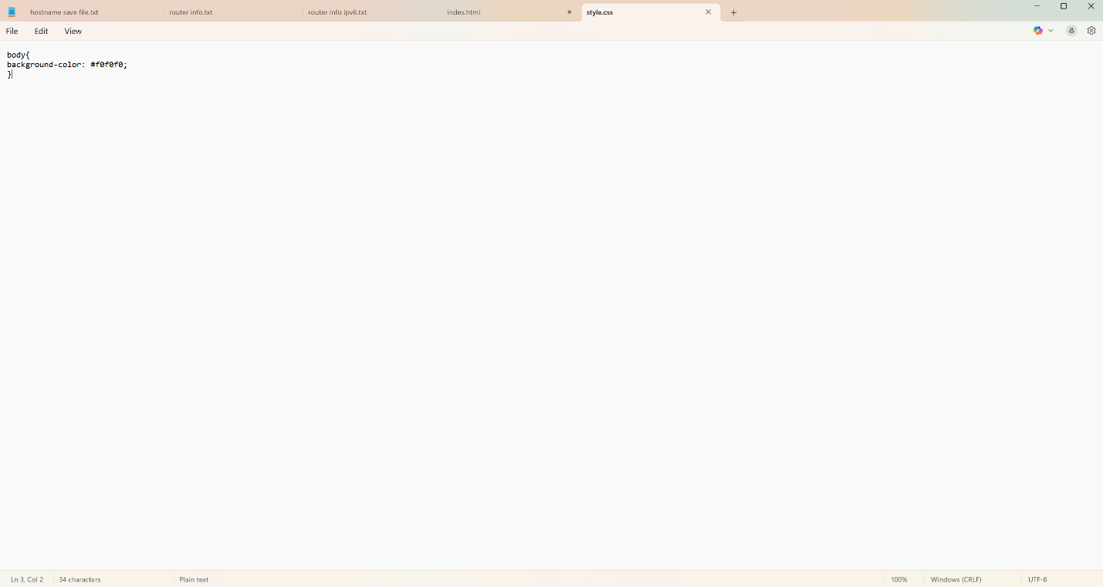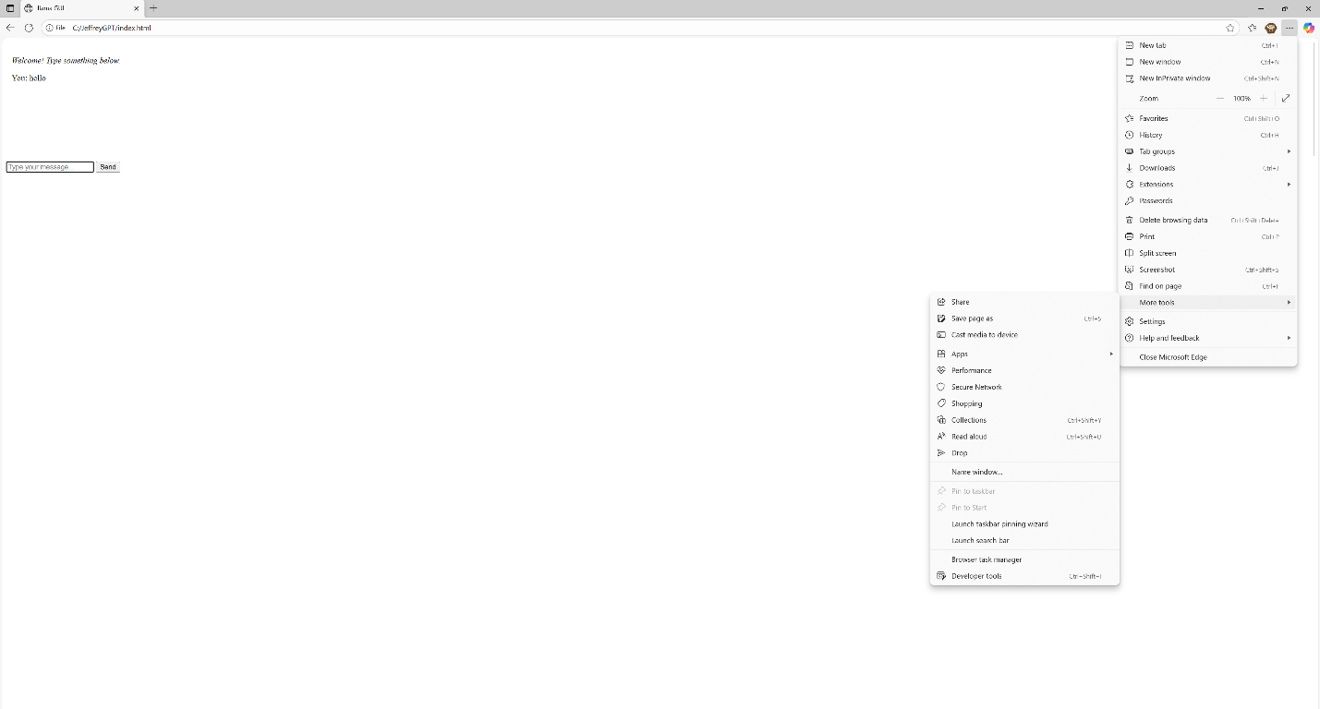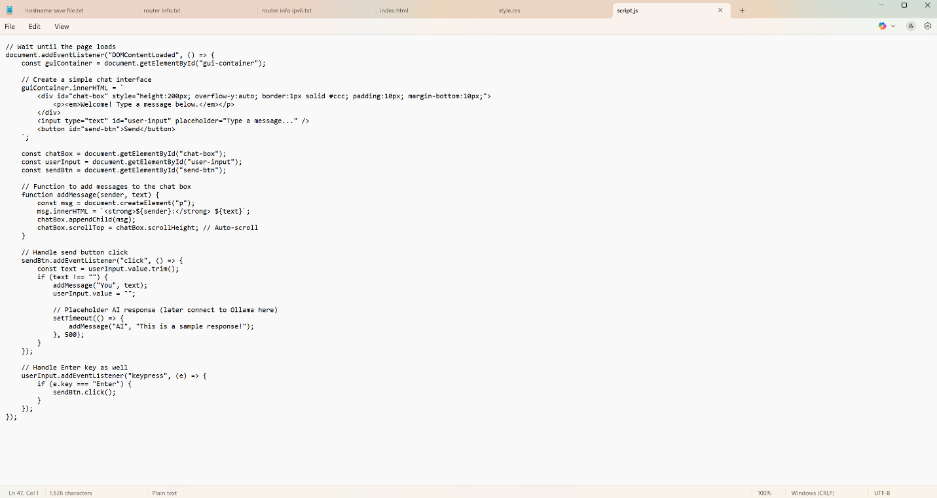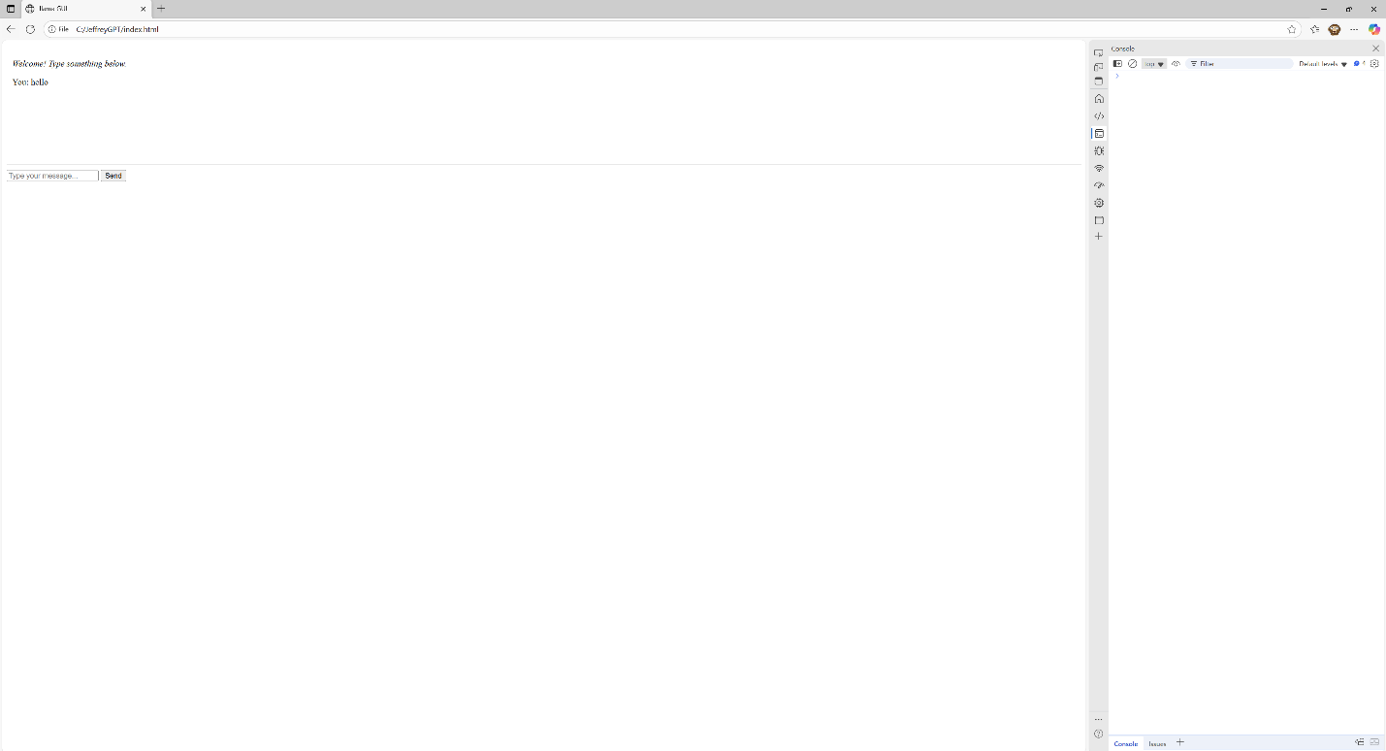
Problems
The start of the lab was not too troublesome but after finishing the easy part of installing Ollama and docker we were a bit stuck on what to do next. To solve this issue, we grabbed a Jeffrey Cheung and he helped guide us through the rest of the lab. Despite this we had a lot of trouble with PowerShell commands since they could be really confusing. Finding docker guides on PowerShell helps a lot. Also, another possible issue is that an HTML file is not automatically recognized unless you specify it. You must enable file name extensions in the view settings and then rename the file to the correct type. The file’s icon should also change and should not appear as a .txt file.
Conclusion
To conclude the lab, we discovered that it is actually pretty easy to install AI locally and also allow access through a GUI. It was a little time consuming though and the lab could definitely be a lot more work if we were to make our own components through programming, but the GUI provided eliminates that requirement.

